Day 8 : 23 Sep 2024

Front end team -🡪 React JS

Product to orders one to many relationship

Product entity and Orders entity

1. Store the product : passing pid,pname,price, qty etc.
2. Delete the product : using pid
3. Delete the product with price > condition
4. Update the product price and qty using pid
5. Find specific product details using pid
6. Find product details using price > condition
7. Place the orders oid(PK auto increment, dateandtime, qty, pid) etc
8. View all the orders
9. View specific order using pid

Using spring itiliazer we create the project

Starter 🡪 Web Starter for web application to create rest full web servie

Starter 🡪 JPA for ORM or spring data (abstraction for dao layer)

Dependency 🡪 MySQL connector database

Starter -🡪 dev tool if we do any changes automatically project refresh (development mode)

Starter 🡪 Lombok , it provide to avoid setter, getter, toString empty constructor as well as parameter constructor not write those features we use using annotation.

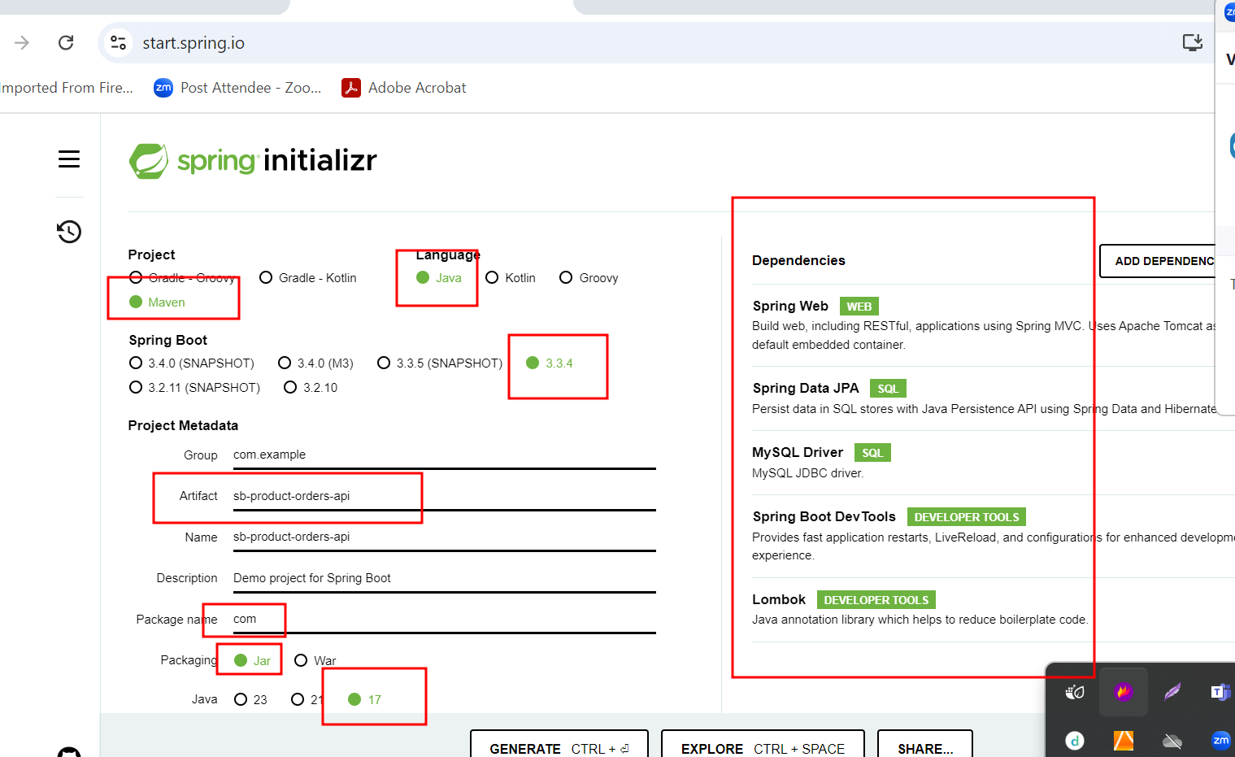

Product

Pid(PK), PName, Price, qty etc

Orders

OID(PK), dateandtime, qty, pid(FK)

@RequestMapping : this annotation we can use on class level as well as method level.

Class level to check base path. Generics annotation ready to receive any type of request.

@GetMapping

@PostMapping

@PutMapping

@PatchMapping

@DeleteMapping

These annotation are method level without method attribute. These are specific annotation.